D. Differentiate between.
1.Closed circuit and open circuit
Closed circuit | Open circuit
Electricity flows in this circuit | Electricity doesn’t flow in this circuit
Electrical appliances works perfectly. | Electrical appliances doesn’t work perfectly.
2.Fuse and MCB
Fuse | MCB
It is cheaper and need to be replaced after it gets melt. | It is expensive and not needed to be replaced .
It doesn’t acts like a switch. | It acts like a switch.
3.Permanent magnet and temporary magnet
Permanent magnet | Temporary magnet
A permanent magnet keeps its magnetism for a long time. | A temporary magnet keeps magnetism for a short time.
For e.g= bar magnet, horse show magnet etc | For e.g = electromagnet
E. Give reason.
1. MCB is advanced than fuse wire.
- because it change th phase during the excessive current and turn off the electric supply.
2.Fuse is safeguard of electrical appliances.
- because it melts and breaks the circuit when excessive current flows, preventing damage and fire.
3. iron filings attract the magnet .
- because it is a magnetic substance and it creates magnetic force when it is near a magnet.
4. Electric magnet is temporary .
- because it works only when electric current flows through it.
F. Very short answer type questions
1. What are the poles of magnet?
-The region of magnet where the attraction capacity is strong is called the poles of magnet.
2.What are the methods of making magnets?
-The methods of making magnets are=
1. Stroking method. 2. Electrical method
3. Name any two devices that use magnet for their functions.
- The two devices that use magnet for their functions are=
1. Radio. 2. Speaker
4. What is used to turn on and turn off the electricity in a circuit?
- A switch is used to turn on and turn off the electricity in a circuit.
5. Define electric circuit.
- Electric circuit is a path through which electric current flows.
6. What happens in fuse when excess current passes through it.
- When excess current passes through fuse, it will melt.
G. Short answer type questions.
1. What type of substances are attracted by a magnet ? Give an example
2. How can you increase the strength of electrical magnet?
- We can increase the strength of electrical magnet by =
1. Increasing the number of turns of wire in the coil.
2. Increasing the current flowing the coil.
3. Name the devices that are powered by electricity at your home .
- The device that are powered by electricity at our home are:-
1. Television 2. Mobile 3. Fridge 4. Speaker
4. Name any four electrical sources.
- The four electrical sources are:-
1. Cell/battery. 2. Photocell. 3. Generator. 4. Dynamo
5. What are the effects of electricity?
- The effects of electricity are:-
1. Heating Effect. 2. Lighting Effect
3. Magnetic Effect 4. Chemical Effect
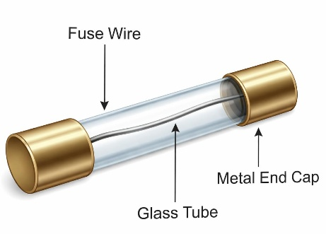
6.Draw a figure of fuse wire.

H. Long answer type questions.
1.What is a magnet? What does magnetic field mean?

2. Describe the stroking method of making magnet.

3.Discuss the electrical method of making a magnet.

4.Define electric circuit. Draw a closed electric circuit showing a bulh dry cell, connecting wires and a switch.

- Draw a symbolic figure of an electric circuit showing a bulb, a cell, connecting wires and a switch.

- Which is the most common effect of electricity? Describe the examples of such common effects.

- What is simple cell? How is it constructed?

- Name the following electric symbols.

F

V

A

- If there is a problem of shorting down of MCB frequently in your home. Your father gets an idea to give the support to the MCB with a dry wood so that the MCB prevents shorting down. What do you suggest to your father, is this a good idea to resolve the problem?

- Write short note on “Electricity is essential in this modern world”.

